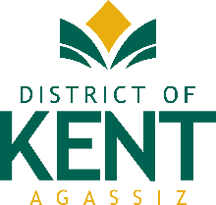

FOR IMMEDIATE RELEASE

February 29, 2024

District of Kent Receives Canadian Award for Financial Reporting

Agassiz, British Columbia – The Canadian Award for Financial Reporting has been awarded the District of Kent by the Government Finance Officers Association of the United States and Canada (GFOA) for the annual financial report of 2022. The Canadian Award for Financial Reporting Program was established to encourage municipal governments throughout Canada to publish high-quality financial reports and to provide peer recognition and technical guidance for officials preparing these reports. Its attainment represents a significant accomplishment by a government and its management.

The 2022 annual financial report has been judged by impartial Canadian Review Committee members to meet the high standards of the program, including demonstrating a constructive “spirit of full disclosure” designed to clearly communicate the municipality’s financial story and to motivate potential users and user groups to read the report.

Mayor Pranger congratulated the Director of Financial Services, Mike Veenbaas, and the entire department on receiving this achievement once again.

-30-
Mayor Sylvia Pranger
District of Kent
604-796-2235
info@kentbc.ca

